Linux install

Wsl install

Task 1:

Create a Directory with the Name Linux Practice.

Hint: use mkdir LinuxPractice

Task2:

Change to the directory

Hint: use cd .\LinuxPractice\

Task 3:

Create a file name TestFile1.txt and add the content to it.

Task 4:

Create a Folder named Dummy and try to delete it.

Task 5:

Plz check the working directory (Hint : pwd)

Task 6:

How do you check all the files and directories in the directory you are in?

Task 7:

Create five files named TestFile2.txt.. TestFile3.txt… and so on till TestFile6.txt

Task 8:

Copy all files from Dir 1 ti Dir 2

Task 9:

Move all files from Dir 2 to Dir 3 (finally ur Dir 2 should be empty)

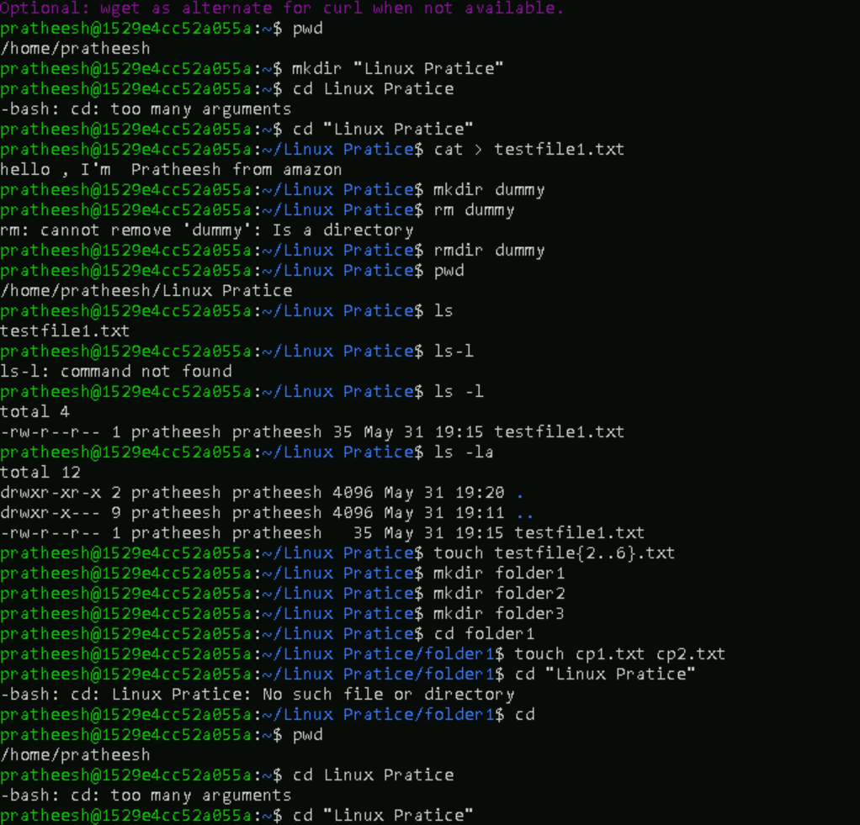

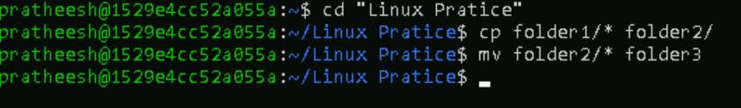

Task 10:

Can you plz show me the diff between **rm** and **rmdir** commands with screen shots ?

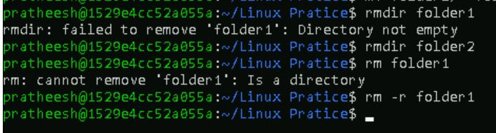

Task 11:

Now use specifically use cat command to create a file

And add the dummy text of 2 to 3 paragraphs from the above link Lorem Ipsum.

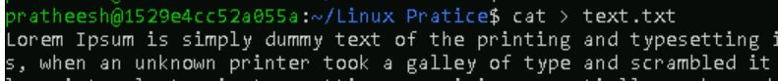

Task 12:

How to get only the top part of your file..

Hint: use head

Task 13:

How to get only the last part of your file

Hint: use tail

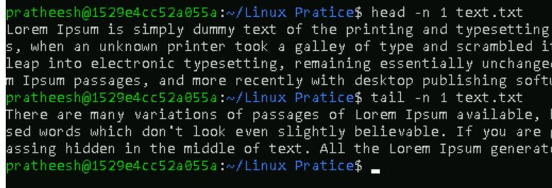

Task 14:

Plz add dummy text of 5 to 6 pages in to the same file

And

Now show the file in page by page

Hint : use less command

Task 15:

Use more command on the above file and find out the diff between less command and more command.

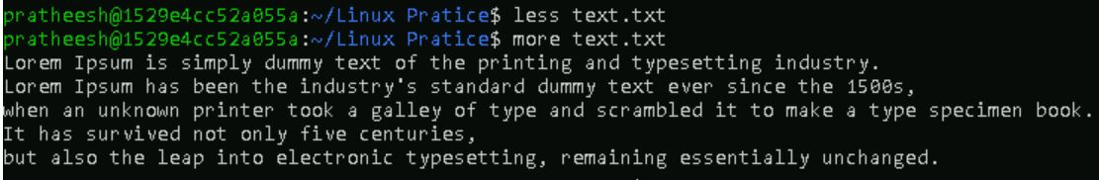

Less command

Scroll forward and backward , faster for large files

More command

Scroll forward only , slower for large files

Task 16:

Can you use echo command with -e and see the diff.. Also take a ss and paste

What is e in echo command..?

The e in the echo command is an option that enables the interpretation of backslash escape sequences. These sequences allow you to insert special characters and formatting into the output.

echo -e "Hello\nWorld"

Hello

World

echo "Hello\nWorld"

Hello\nWorld

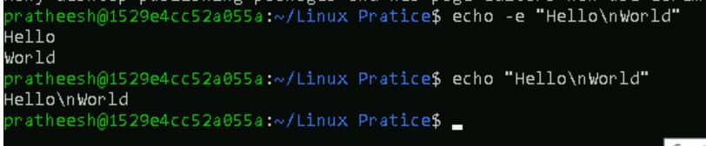

What is diff between ls and ls -l command .. ss plz

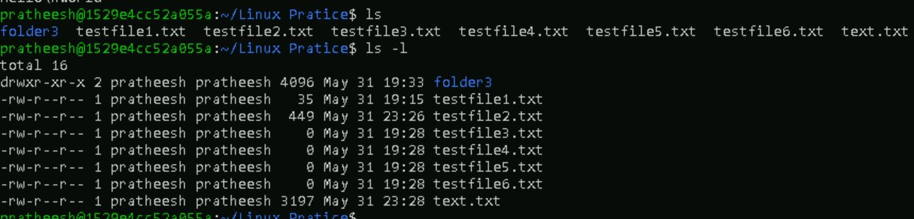

ls > Shows **only names** of files and directories.

ls -l > Shows **detailed information** about each file.

Task 18:

Create a file using **touch** command , **cat** command and **echo** command and take ss (screen shot)..



Touch = Creates a new, empty file Does not add content to the file

Cat = Displays the contents of a file.create files with content interactively

Echo = Prints text to the terminal or writes it to a file.Often used to add lines to files.

Task 19:

Can you guys try to display the calendar by using a command..

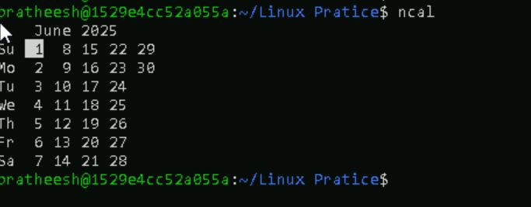

Task 20:

Can you go back to 1 directory .. at a time whats the command

Command cd

Task 21:

How to know whose user u are working on ?

Hint: use whoami command

Task 22:

Try to find out who is peeping into your system..

Hint: Use users, who and w commands with ss

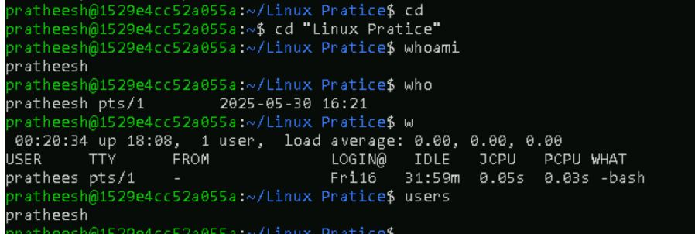

Task 23:

Can you guys try to check how much disk space is consumed..

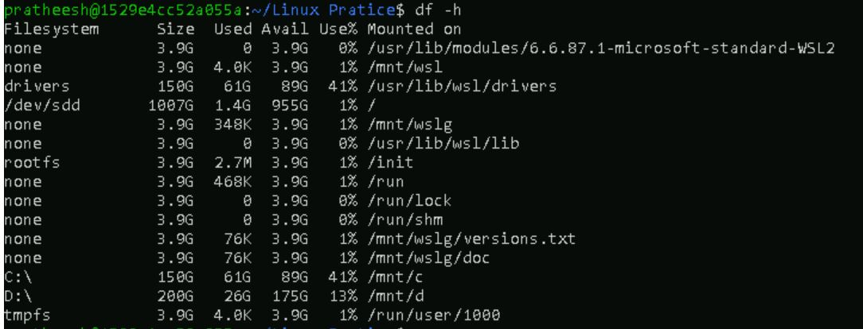

Task 24:

In the **ls -l** listing example, every file line begins with a **d**, **-**, or **l**. These characters indicate the type of the file that's listed.

Can you plz try using the below commands

Task 25:

Find the list pf all files ending with .txt

Hint : use * in ls

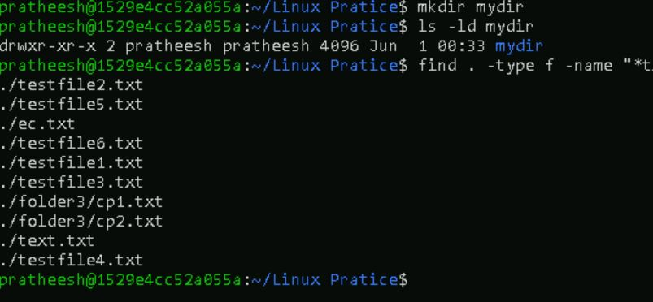



Task 26:

In Linux all the hidden files starts with . (period)

How to check all the hidden files in Linux..

Hint : use ls -a

Task 27:

What is the difference between . and .. in linux

Line 1 line for each

. refers to the **current directory**.

.. refers to the **parent directory** (one level up).

Task 28:

Can you create a file using vi editor and show the details in ss

Task 29:How to find the no of words in the file

Hint: use wc

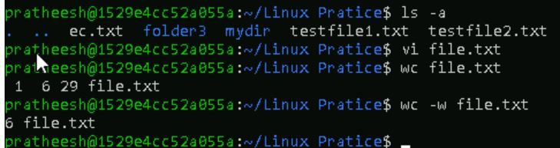

Task 30:

What is the use of cat -b myfilename.txt command?

Task 31:

Can I use the wc with 2 or more files?

Wc file1 file2 file3

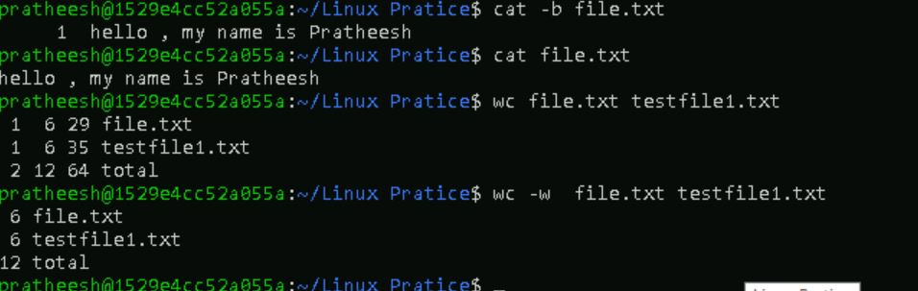

Task 32:

How to copy content of one file to another file

Hint: use cp:

Task 33:

Now I want to rename my file with MYFILENEW can i do that if so how ?

Hint use : mv

Task 34:

Can i remove or delete multiple files in linux..? How?

Task 35:

In directory / slash is root … can you try cd / what is it doing?

Task 36:

What is the way go go to home directory ?

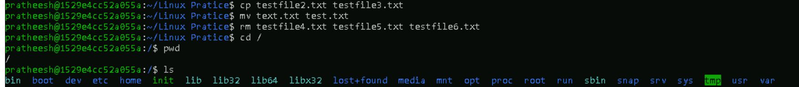

Task 37:

If i want to move to different users home directory

Hint : use ~username

Task 38:

Chmods:

